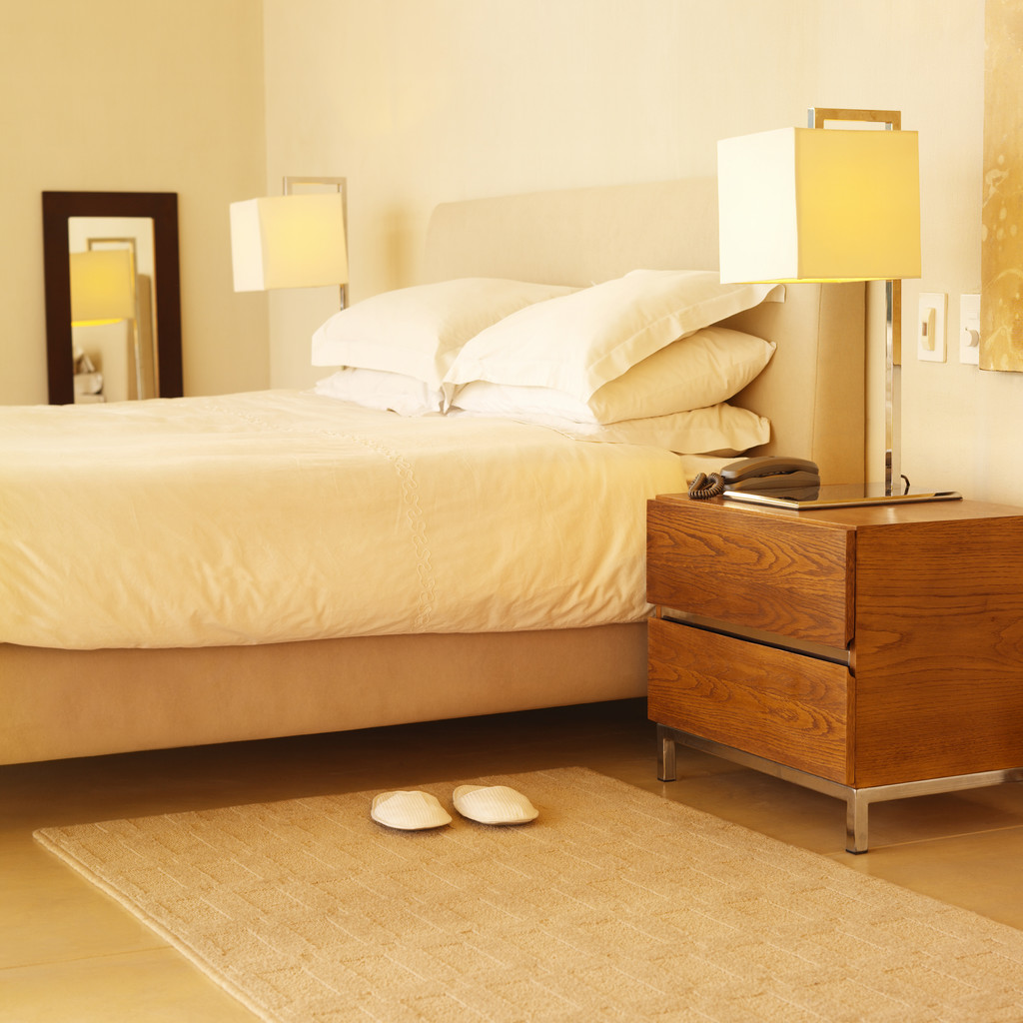

Your Hotel Name
Address
T +99-999-9999999
F +99-999-9999999
E: admin@setupmyhotel.com
W: www.setupmyhotel.com
( Date )
(Full Guest Name)
Room : (Room Number of guest )
Dear Mr / Mrs. ( Guest Salutation and Guest Name)

Welcome to (Your Hotel Name)!

Thank you for choosing (Your Hotel Name) which offers a blend of Eastern and
Western hospitality in an atmosphere of timeless elegance, beyond comfortable
and stylish rooms, unmatched Sea view.

it’s the people of (Your Hotel Name) who will make your experience truly exceptional.
Our all rooms are equipped with conveniences like air-conditioning, satellite TV,
DVD, mini-bar, IDD telephone, a writing desk, a fax machine,
high speed internet access and a radio with alarm clock.

Additionally each room has a smoke detectors and sprinklers.

The large bathrooms feature a separate toilet, a shower and a bath.

Our Hotel has Four non-smoking floors and Baby cots are also available with a surcharge.

Should you require any additional help or information during your stay with us,
please do not hesitate to contact our Duty Mangers at their desk in the lobby or
dial extension #9 from your room.

Wish you a pleasant staying, thank you
Best regards,
Hotel Management

