( Date )
(Full Guest Name)
Room : (Room Number of guest )
Dear Mr / Mrs. ( Guest Salutation and Guest Name)
Welcome to ( Your Hotel Name ). On behalf of all my staff, I hope you will be having a wonderful stay here.
The Management and staff are pleased to be your hosts. I look forward to demonstrating services and skills distinctive and special to (Your Hotel Name), which is fully equipped with fine dining, Spas , business centre and Health club facilities to cater to our guests.
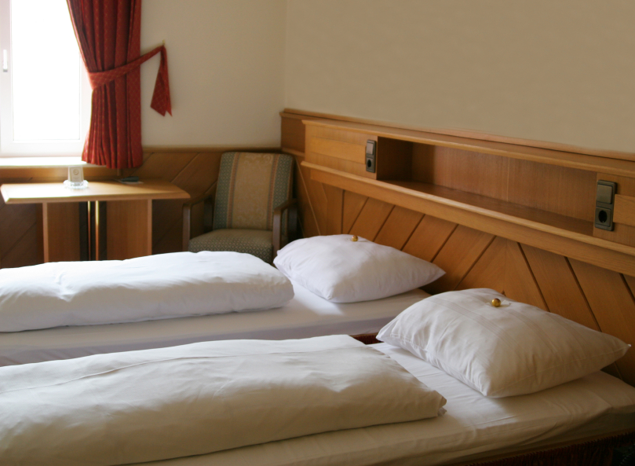
Your Hotel Name
Address
T +99-999-9999999
F +99-999-9999999
E: admin@setupmyhotel.com
W: www.setupmyhotel.com

At ( Your Hotel Name ), we promise to serve you better. We want to be attentive and sensitive to your needs. We also seek to be innovative in meeting and also exceeding your expectations.
Should you require any additional help or information during your stay with us, please do not hesitate to contact our Duty Mangers at their desk in the lobby or dial extension #9 from your room.
May I take this opportunity to thank you for having chosen the ** Hotel and we look forward to serving you again in the near future.
Yours sincerely,
General Manager

