[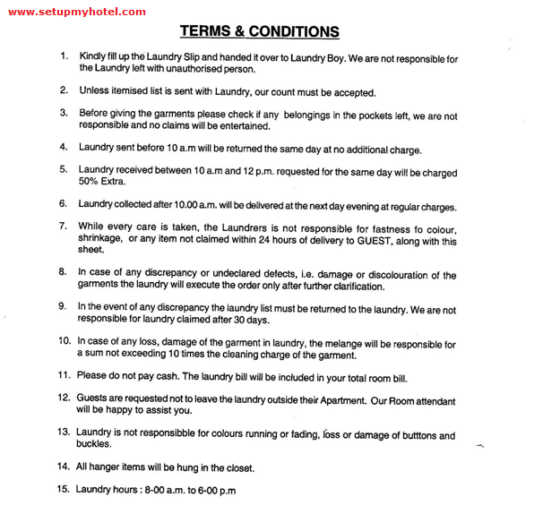](http://www.setupmyhotel.com)