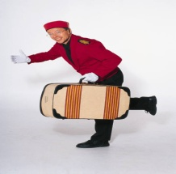

 |  |  | ARRIVAL
Hotel Logo
Date: ………………….. |  |  |  |  | Room No:
Guest Name: ………………………………………………………
Company Name : ………………………………………………...
Group Name: …………………………………………………….
 |  |  | Baggage Details
Strolley |  |  | Suitecase |  |  | Travel Bag
Breifcase |  |  | Laptop |  |  | Handbags
Notes:
Baggage Screening Done :
Bell Desk |  |  | Duty Manager |  |  | Cashier
ERRAND CARD

